Task 4: Designing and Modelling Deliverable
Package Diagram
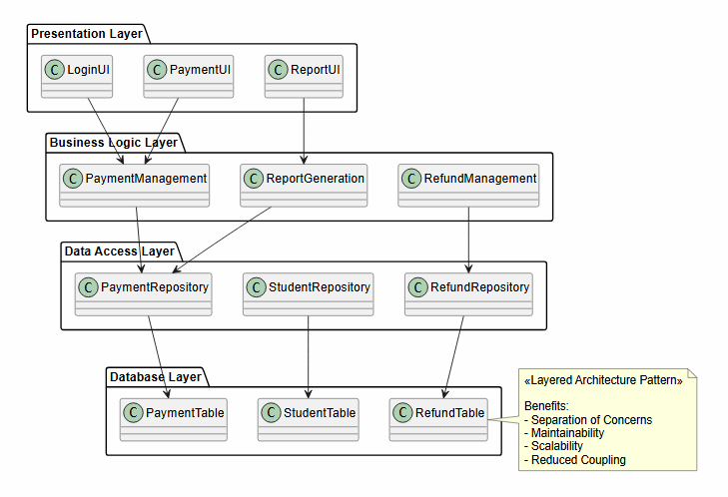
This package diagram shows the Layered Architecture Pattern used in the Fee Management System, where the system is organized into Presentation, Business Logic, Data Access, and Database layers, each with a distinct responsibility. The diagram illustrates how user interactions, business processes, data access operations, and data storage are separated to maintain a clear flow of information. The key design decision recorded in this diagram is the adoption of a layered architecture to separate concerns and reduce coupling between system components, making the system easier to maintain, test, and extend as requirements evolve.

Deployment Diagram
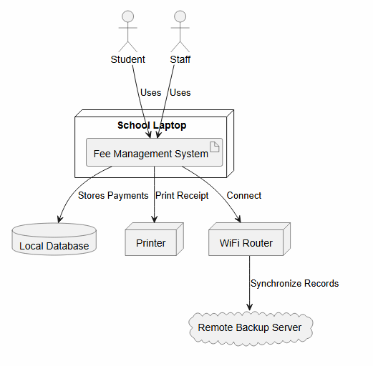
The deployment diagram shows the physical architecture of the Fee Management System and how hardware and software components interact when a parent accesses the System through a school laptop, the main device used to process fee transactions for Kina Ridge Primary School. The application runs on a school laptop used by students or staff to process payments. Payment records are stored in a local database, receipts are printed through a connected printer, and data is synchronized through a WiFi router to a remote backup server when internet connectivity is available. This design supports both offline operation and secure backup of financial records because a remote backup server was included to support automatic synchronization and backup of payment records. This decision reduces the risk of data loss and allows the system to continue operating locally when internet connectivity is unavailable.

Use Case Diagram
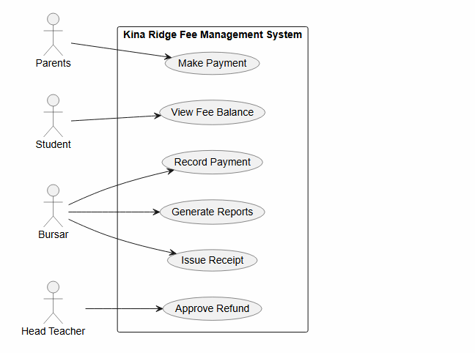
This use case diagram shows the interactions between users and the Kina Ridge Fee Management System. The actors include Parents, Students, Bursars, and the Head Teacher, each performing specific functions within the system. Parents can make fee payments, students can view fee balances, bursars can record payments, generate reports, and issue receipts, while the Head Teacher can approve refunds. The system boundary identifies the functions provided by the system and the actors that interact with them. A key design decision recorded in this diagram is the implementation of role-based access control, where each user is limited to specific use cases based on their responsibilities. This decision improves security and accountability by ensuring that users can only access functions relevant to their role.

Class Diagram
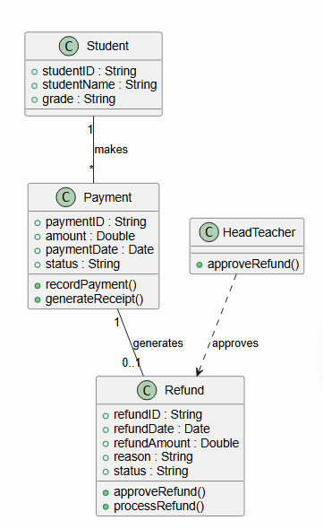
This class diagram shows the structural design of the Fee Management System. It identifies the main classes involved in the system, including Student, Payment, Refund, and Head Teacher, along with their attributes, operations, and relationships. This diagram shows that the student can make multiple payments, a payment can optionally generate a refund, and refund requests require approval before they are processed.
A key design decision recorded in this diagram is the introduction of a separate Refund class rather than storing refund information within the Payment class. This decision separates payment processing from refund management, making the system easier to maintain and extend while ensuring consistency with the refund workflow shown in the state diagram. The design also supports controlled refund processing through Head Teacher approval.

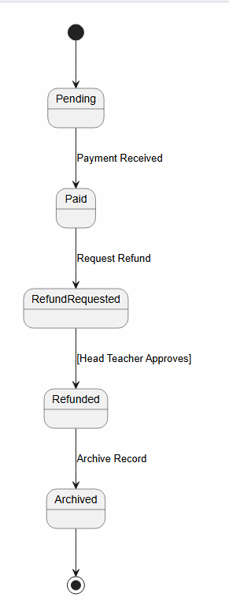
State Diagram
This state diagram shows the lifecycle of a payment transaction in the Fee Management System, progressing through the states Pending, Paid, RefundRequested, Refunded, and Archived. It illustrates how payment records move through the system as payments are received, refunds are requested, approvals are granted, and records are archived. A key design decision recorded in this diagram is that refunds cannot be processed until the Head Teacher approves the request, as indicated by the [Head Teacher Approves] guard condition. This decision improves accountability and financial control by helping prevent unauthorized refund transactions.

Activity Diagram
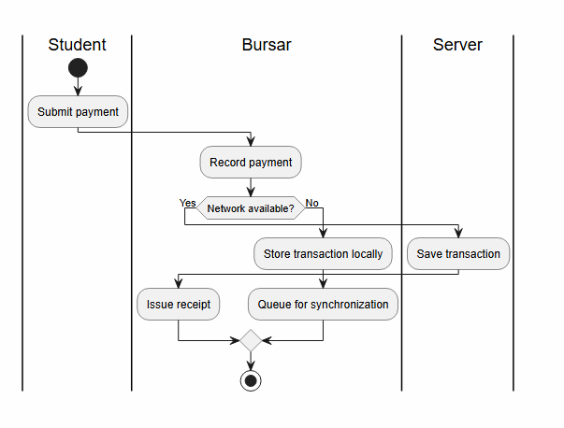
This activity diagram models the workflow for processing student fee payments and shows how different participants interact throughout the process. The process begins in the Student swimlane when a student submits a payment. The activity then moves to the Bursar swimlane, where the bursar records the payment. A decision point checks whether the network is available. If the network is available, the transaction is saved directly on the server. If the network is unavailable, the payment is stored locally and queued for synchronization when connectivity is restored. After either path is completed, the bursar issues a receipt and the process ends. This diagram highlights the system's offline capability, ensuring that payment processing can continue even when internet connectivity is unavailable, which is important for schools operating in areas with unreliable network access.

AI Declaration
Microsoft Copilot was used to assist with editing and improving the wording of explanations in this addendum and improving each diagram.

